Chapter 12, Problem 64.

For the circuit in Fig. 12.58, use PSpice to find the line currents and the phase currents.

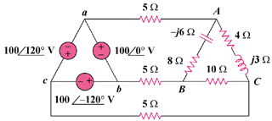

Figure 12.58
For Prob. 12.64.

